Suspense account

It happened when differences in journal and trial balance, 95 % we should not recommend to client
Setups
- Enter suspense account at ledger options
- Enter unbalanced journal
- Verify posted journals

Enter suspense account at ledger options

- Go to set up and maintenance
- Set up: Financials
- Task: %specify% ledger%
- Select Specify ledger options
- Give the suspense account under journal processing
- Save and close

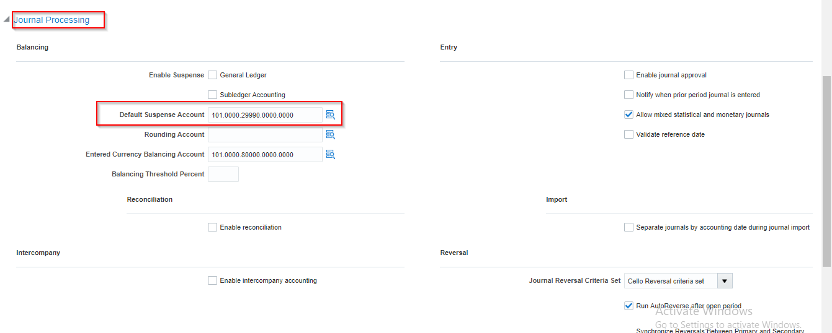

Enter unbalanced journal

- Go to navigator
- Go to General accounting
- Select the Journals
- Click on Task icon
- Create journals
- Enter unbalanced lines, save ad post it
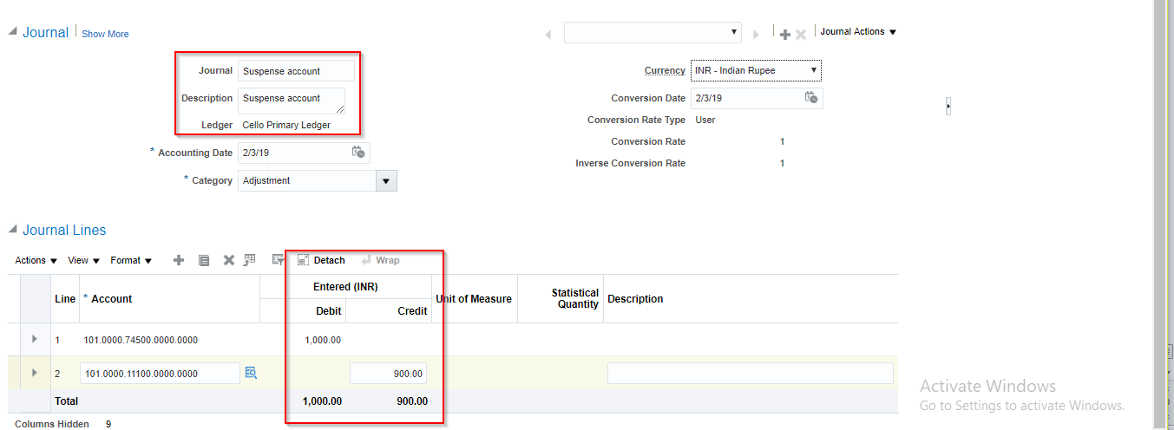
Note: If we not entering the suspense account in ledger option it will not post it because as per Balancing segment label

Verify posted journal

- Go to navigator
- Go to General accounting
- Select journals
- Click on Task icon
- Mange generals
- Un balanced amount adjusted to suspense account

